Pennsylvania District of Circle K
2022-2023 District Convention
Dress Code and Packing list
A dress code will be in place for the District Convention. All attendees are expected to follow the dress code and always look appropriate. Violators will be asked to change. The following code is in place for the weekend:

Casual: Opening Session, Fun Fellowship Activities, LSSP, and Service Room
Business-casual: Kiwanis Family Lunch, Divisional Caucusing, Workshops, and Farewell Session Business-professional: House of Delegates, and President’s Banquet
We recommend that you bring the following:
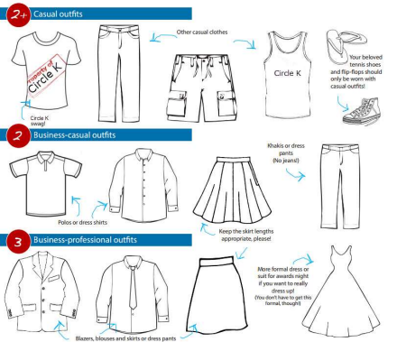
Additional Items:
✓ Delegate Certification Form
✓ Medical and Code of Conduct Forms
✓ Award and Contest Forms
✓ Spending Money – some meals will be on your own!
✓ Money for Fundraisers
✓ Camera
✓ Water Bottle
✓ Prescription Medication
✓ Toiletries

